DOCKER TASK 2

1.Create a tomcat container on 8080 and deploy sample application in tomcat.

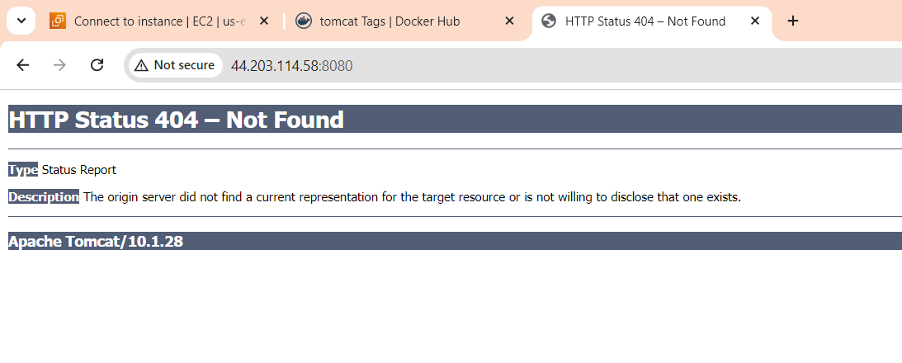

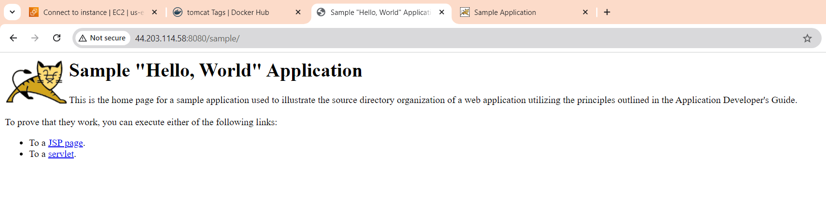

2.Create volume and deploy tomcat container on port 8081.

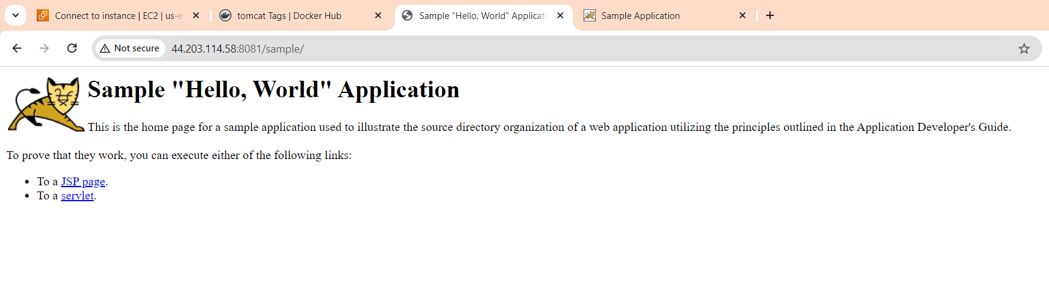

3.Limit the nginx container to 500 MB.

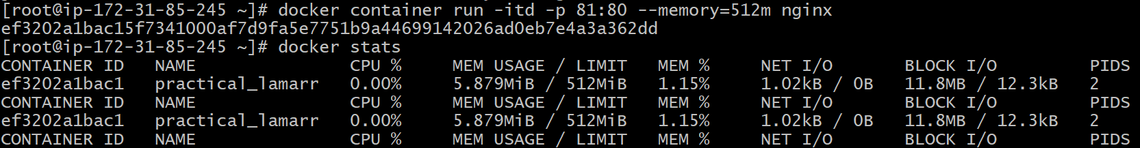

4. Create a sample docker file using below instructions. 1) Base module as amazonlinux:latest

2) Maintainer you name

3) Install nginx

4) COPY one index.html file to image

5) EXPOSE on port 80

6) CMD to start the nginx container

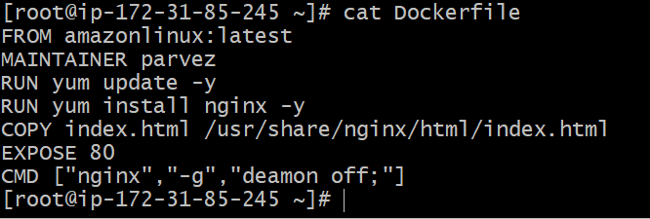

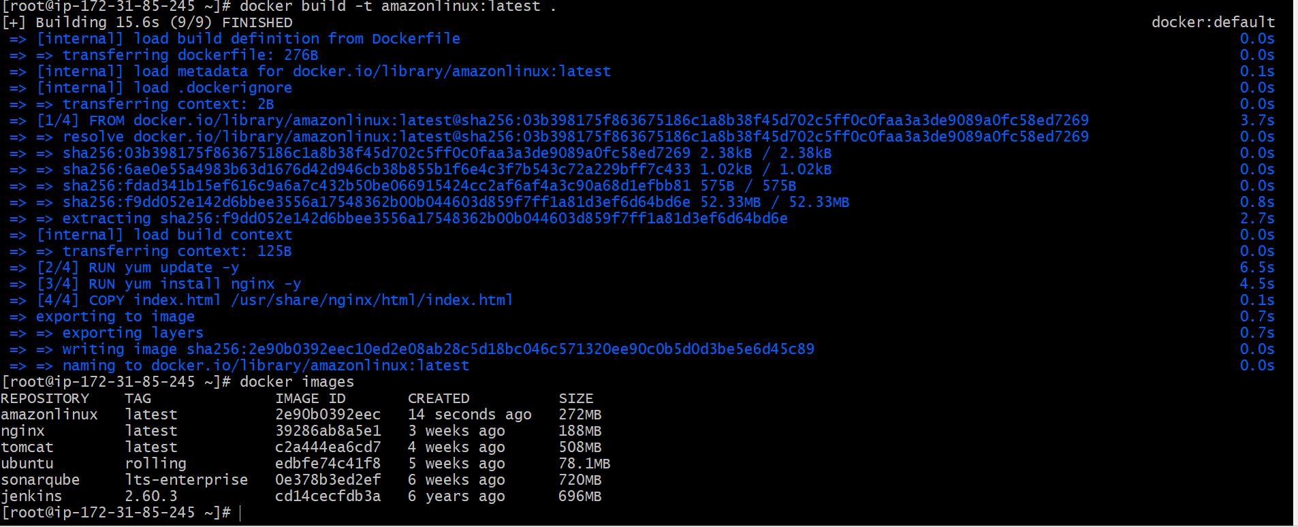

5.Push image to docker hub

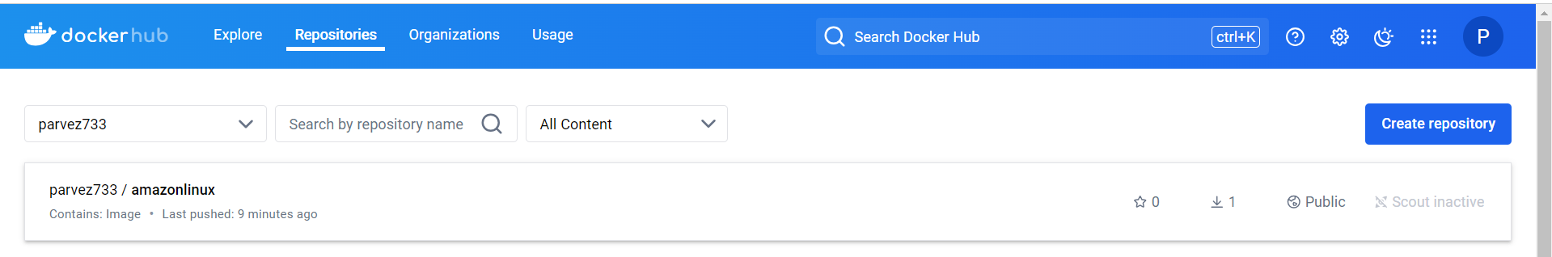

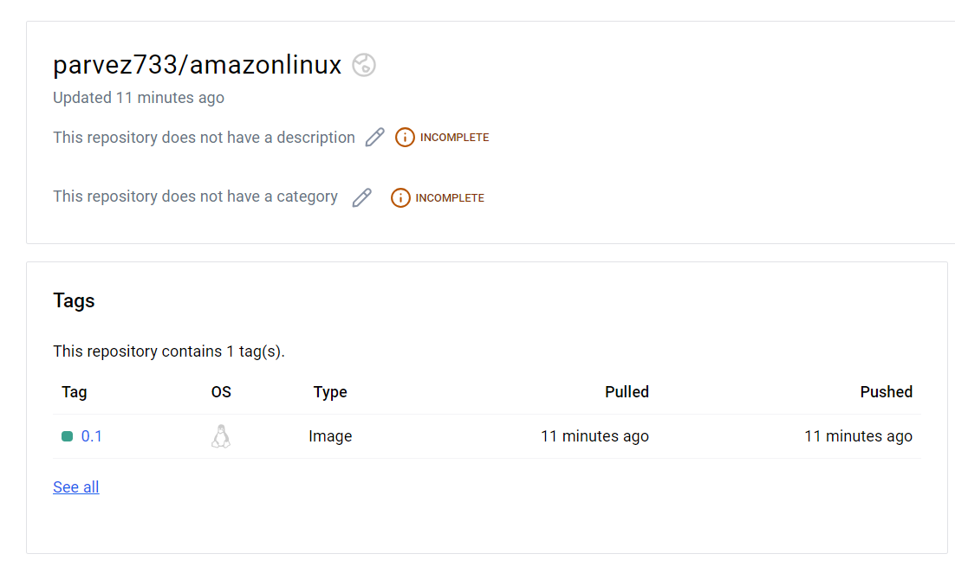

6.push image to aws ecr

